THE PARISH OF LONG POINT BAY
Port rowan port ryerse turkey point vittoria St. John’s woodhouse
Sunday February 27th 2022
Last Sunday after Epiphany – The Transfiguration

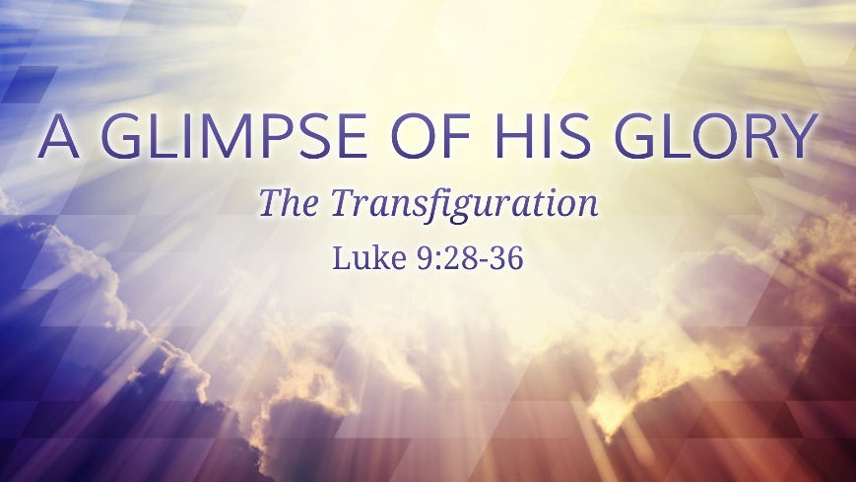
Opening
The grace of our Lord Jesus Christ, and the love of God, and the fellowship of the Holy Spirit, be with you all.

Sentence
This is my beloved Son, with whom I am well pleased; listen to him.
Matthew 17.5

Collect
Almighty God, on the holy mount you revealed to chosen witnesses
your well-beloved Son, wonderfully transfigured:
mercifully deliver us from the darkness of this world,
and change us into his likeness from glory to glory;
through Jesus Christ our Lord who lives and reigns with you and the Holy Spirit,
one God, now and for ever.

Readings
EXODUS 34:29-35;

PSALM 99;

2 CORINTHIANS 3:12-4:2;

LUKE 9:28-36 (37-43A)

https://lectionary.anglican.ca/nrsv/?date=2022-02-27&submit=show+new+date

Reflection for Sunday February 27th

The human spirit has the remarkable capacity to hope. Hope can be formed around the tiniest speck, the smallest inkling, the fewest words. But there has to be something—a vision, an experience, a memory, another’s word, to serve as the seed from which hope grows. There is no hope in a vacuum, there is no faith in a void.

Today’s readings centre on the Transfiguration of Jesus before his testing, trial, and crucifixion in Jerusalem. The transfiguration is a brilliant example of God at his clearest—a moment when hope and faith are replaced, for the moment, with sight and certainty. It is a bold testament to God’s glory. But this is not just about God, either. God is certainly God in heaven and on earth, in moments when he is revealed and, in those moments, when God seems hidden, too. Moments like the transfiguration reinforce the relationship, between God and his creation. God isn’t just God, God is revealed to you, God is God for you. Both of those things are important.
The transfiguration holds a prominent place in the imagination of the people of God. It is a foundation for faith when God does not seem to be around, when the darkness closes in. Moments like the transfiguration, Jesus’ baptism, Moses’ excursion to the mountain top and encounter with a burning bush, they are meant to bring some semblance of light, some semblance of hope, into the darkest of times.

God, in these passages, is God may not seem to be here now, but I remember when he was revealed in Glory, and he is greater than anything we face.
Now that was of speaking is true, but it isn’t the whole story. That way of speaking makes God an external hope. When we don’t see God in our situation, we can look beyond it all to the God who is still at work.

But more is true. God is God everywhere, but God doesn’t just stay God-out-there. God is not only a hook to hang one’s hope on. Moments like the transfiguration reveal the certainty of hope in this Jesus, but the transfiguration is far from the end of the story. In Paul’s letter to the Corinthians, he tells us about how that external hope has come to live in us. When Moses met God, writes the apostle Paul, he needed to veil his face. But there is no longer any such barrier. God’s Spirit lives in us. God is alive in us. That place where we hang our hope is not longer at work somewhere out there, the Holy Spirit fills us to the brim with hope and light in despair and darkness.

There is no hope in a vacuum, there is no faith in a void. When all is dark, we can look to moments like the transfiguration and see that our hope is sure, and the God who is at work for our salvation is great. But in the in between moments, when all is not right, and our salvation seems only a faint memory that we once held, the transfigured light of the world is waiting inside, alive in you, the first fruits of more to come. You can trust in God, and you can trust that you are never ever alone. That great God whose face once shone for Moses and the apostles is even now at work for your salvation—not on some distant celestial plane, but right here, right now, always and ever alive in you. Thanks be to God.

The Rev’d Dr. Justin Comber
Rector, Parish of the Transfiguration
(519) 809-9452
justincomber@diohuron.org
parishofthetransfiguration.net

A prayer for Ukraine
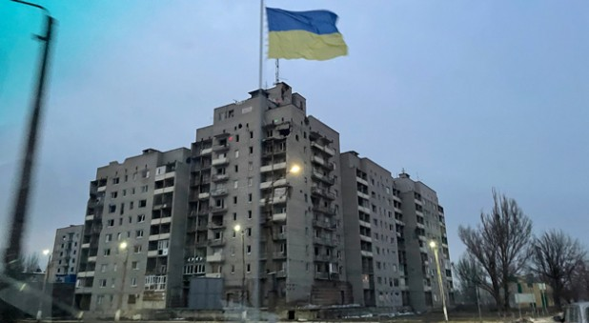
24 February, 2022 Kanishka Raffel

The world is dismayed, though perhaps not surprised, to find that Russia has illegally invaded Ukraine in an act of unprovoked and unjustified aggression. We fear that the toll on the brave people of Ukraine will be heartrending and dreadful. The world has had to engage in defensive action to protect the innocent and to contain aggressors in the past.
We must pray for the government and people of Ukraine, the people of Russia who live under an authoritarian regime, for the leaders of the world that they will respond with wisdom and courage and for the restraint of evil and the restoration of peace, with justice.
Psalm 10 says “Arise, LORD! Lift up your hand, O God. Do not forget the helpless.”
And so we ask -
Sovereign Lord, you observe all those who dwell on earth. Have mercy we pray on those who now suffer the miseries of a war not of their own making. Have compassion on the wounded and dying; comfort the broken-hearted; confound the hatred and madness of those who make war; guide our rulers, bring war to an end, bring peace across the world. Unite us all under the reign of your Son, the Prince of Peace, before whose judgement seat the rulers of the world will give account, and in whose name we pray. Amen.
Archbishop Kanishka Raffel,
Sydney, February 24, 2022

Prayers for Sunday 27th February, 2022, from Mary Field jamar@kwic.com
We are all in need of the saving help of Jesus Christ. Salvation is in Christ alone, by grace alone, through faith alone.
Lord, in your mercy: hear our prayer
Loving God, bless and guide our ministers and leaders as we enter the Lenten season of penitence and discipline, help us to be alive to your Spirit.
Mighty God, we pray for our troubled world and national leaders as they live through conflicts, struggle with terrorism and continue to fight the Pandemic.
Father God, we pray for the families and communities that we may have a spirit of generosity, respect and understanding at all times and may we always be able to help each other just as you love and help us.
Almighty God, we place into your gentle hands those who are sick ease their pain, and heal the damage done to them in body, mind or spirit. Be with them through the support of their friends, families, doctors and nurses and help them to be aware that they are surrounded with the prayers of the faithful.
Almighty God, we reach out in sincere prayer for your intervention in a world fraught with anxiety in the face of aggression, we are especially thinking of those in Ukraine and surrounding area.
Almighty God we pray for Canada in these troubled times.
Merciful God, we remember with thanksgiving those whom we have placed in Your care. Be especially close to those they have left behind.
Faithful God, in the week that lies before us may we reflect your love in the way that we live our lives so that the world can see that we are followers of Christ and by our words and actions draw others into his loving care.
Merciful father: accept these prayers for the sake of your Son, our Saviour, Jesus Christ. Amen
We pray especially for Todd our Bishop, Anne our Metropolitan, Linda our Primate, Mark National Indigenous Archbishop, Marinez Bishop of Amazonia, AD Rick Jones, Rev Enrique Martinez, and Rev Jack Cox.
For the week beginning Sunday 27 February 2022, we will be praying for the Rev. Bill Graham (interim) and the people of Trinity, Waterford

We pray for the ones who have asked for your healing touch upon their lives: Betty F., Don G., Franz and Elaine Z., Steven K., Rebecca M., Trista P., Bill MC., Dwayne M. and Andrea B., Susan A., Olivia H., Karen M., Delores B., Dale F, Rose G, Julie, Carol M., George F., Carol H., Bud W. Juanita K. Mary B. Colin C. his father Michael and all their family and anyone known to you, silently or aloud

Remember as well our shut-ins June, Shirley & John, Iris, Julie, Sheila, Sylvia, Anna and Jack B

It is important that we keep the prayer list and shut-in list up to date. If you know of any changes to these lists, can you please email Anne at lpbparishsecretary@gmail.com or Enrique at enrique6921@gmail.com

If you know of anyone that has asked you to pray for them let us know and we will add to the list

Prayer of Confession
Search us O God and know our hearts today
Try us and know our anxious thoughts,
see if there are any hurtful ways in us
and lead us in your loving and life-giving Way

Words of Assurance
God knows our secret fears, ignorance & selfish ways.
God forgives, forgive yourself, forgive others
Amen

Closing Prayer
God our strength and salvation, receive all we offer you today, and grant that we who have confessed your name, and received new life in baptism, may live in the joy of the resurrection, through Jesus Christ the Lord, Amen

Doxology
Glory to God, whose power, working in us, can do infinitely more than we can ask or imagine. Glory to God from generation to generation, in the Church and in Christ Jesus, for ever and ever. Amen.

Please click on the link to watch this week’s Parish Video

https://youtu.be/LUuWUhJebuU

ANNOUNCEMENTS
In house worship today St John’s Port Rowan at 10 am
Please bring donations for the food bank

Ash Wednesday service – St. John’s Port Rowan 6pm
All in person services to be determined – I will send schedule as soon as decided

Bi-Weekly newspaper
Any good movies you’ve seen or books you have read. A delicious recipe you want to us all to enjoy. Do you have memories you want to share? Please send them to Rev. Enrique or myself and we can include in the newspaper.

Any birthdays/anniversaries/special occasions in March – Let me know for the newspaper. We can celebrate you and add some facts that happened on that day in history. I don't need your year of birth, just the month and date. Of course, if you have a special age birthday and want to celebrate it just let me know. If you are interested in this special occasion section, please send me details.

Dear friends,
With decreases in the rates of COVID-19 infections across our Diocese and the approach of the holy season of Lent, Bishop Townshend has authorized some changes to our COVID-19 protocols. Reopening our Churches Lent 2022 may be found here.
These changes to our protocols, which come into effect on Ash Wednesday, March 2nd, include:
• Capacity limits for worship are now the number of persons that can be seated while physically distanced. (p.1)
• Worship services may now be up to 60 minutes in length. (p.1)
• The common cup may be re-introduced. (p. 2 and. p.11) For an epidemiologist/priest's perspective on the safety of the common cup, please see this article by the Reverend Michael Garner of the Diocese of Ottawa.
• For Lent and Holy Week 2022 only, (and may include Easter Sunday), parishes may institute a new worship service---outside of their existing and continuing schedule of services---that requires proof of vaccination to attend. (p.2)
• The officiant or presider at a service may greet the congregation following the service in a contact-less manner (p.9)
What has not changed:
• Facemasks must be worn at all times by those over 2-years of age who are physically capable of removing them.
• Serving and consumption of food and drink is not permitted except for food sustainability ministries. This restriction will be reviewed in April but for now, we prefer to be cautious in allowing instances where masks are removed. While many of us are greatly missing conversations over a cup of tea or coffee, this is a sacrifice we make to keep one another safe.
Protocols for the Imposition of Ashes, the Washing of Feet and the Veneration of the Cross may be found here.
Should you have any questions about the revised protocols, please do not hesitate to be in touch. May you have a holy Lent.
blessings,
Tanya+
The Venerable Tanya Phibbs
Archdeacon of Huron

Sing along to this mornings Hymns

Hymn Texts – Sunday, February 27, 2022
460 – Lord, the Light of Your Love Is Shining

- Lord, the light of your love is shining, in the midst of the darkness shining,
Jesus, Light of the world, shine upon us; set us free by the truth you now bring us,
Shine on me, shine on me.
Shine, Jesus, shine; fill this land with the Father’s glory;
Blaze, Spirit, blaze: set our hearts on fire.
Flow, river, flow: flood the nations with grace and mercy;
Send forth your word, Lord, and let there be light.

- Lord, I come to your awesome presence, from the shadows into your radiance;
By the blood I many enter your brightness; search me, try me, consume all my darkness,
Shine on me, shine on me.
Shine, Jesus, shine; fill this land with the Father’s glory;
Blaze, Spirit, blaze: set our hearts on fire.
Flow, river, flow: flood the nations with grace and mercy;
Send forth your word, Lord, and let there be light.

- As we gaze on your kingly brightness so our faces display your likeness;
Ever changing from glory to glory, mirrored here may our lives tell your story,
Shine on me, shine on me.
Shine, Jesus, shine; fill this land with the Father’s glory;
Blaze, Spirit, blaze: set our hearts on fire.
Flow, river, flow: flood the nations with grace and mercy;
Send forth your word, Lord, and let there be light.

565 – Guide Me, O Thou Great Jehovah
- Guide me, O thou great Jehovah, pilgrim through this barren land.
I am weak, but thou art might: hold me with thy powerful hand.
Bread of heaven, bread of heaven, feed me till I want no more,
Feed me till I want no more.

- Open now the crystal fountain whence the healing stream doth flow.
Let the fire and cloudy pillar lead me all my journey through.
Strong deliverer, strong deliverer, be thou still my strength and shield,
Be thou still my strength and shield.

- When I tread the verge of Jordan, bid my anxious fears subside;
Death of death, and hell’s destruction, land me safe on Canaan’s side:
Songs of praises, songs of praises, I will ever give to thee,
I will ever give to thee.

CONTACT INFORMATION:

At this extraordinary time if you wish a telephone visit, please call Enrique. If you have any other announcements or news contact Anne Halls at the contacts below.

Enrique Martinez can be contacted by email at enrique6921@gmail.com or
by phone at 519 586 3401 – Please note that Enrique’s day off will be Fridays

Our parish assistant Anne Halls can be contacted by email at lpbparishsecretary@gmail.com or by phone @ 519-586-7034
Please visit our website parishoflongpointbay.com and Facebook page

